For more information, cross-reference this doc with the Art Direction Document made by Vinny.

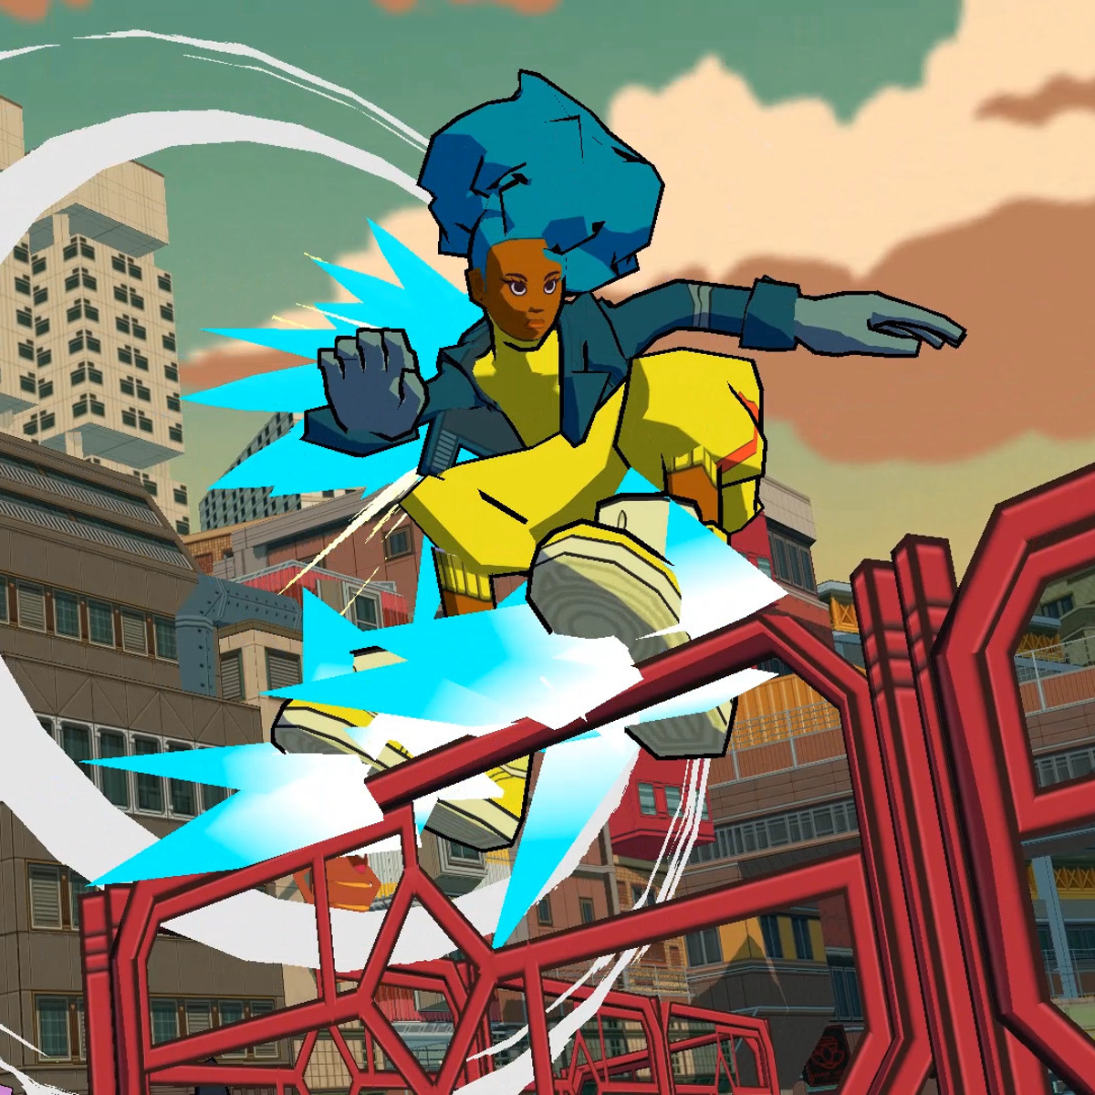The white circles for impact could be used for ground-pound.

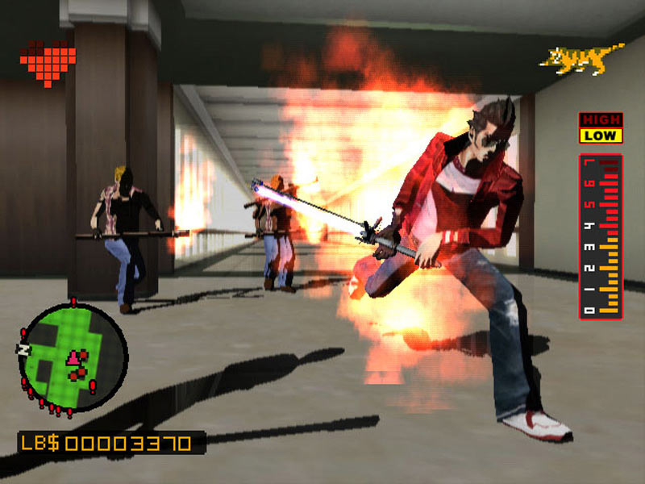
Possible Fire VFX that could run on WebGL.

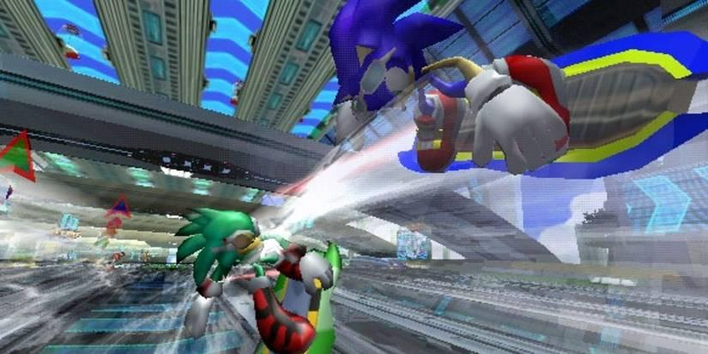 Those white afterimages could also be used (up to you if it looks good or not)

